1. Set up your Outlook to include the Developer tab:

* File 🡪 Options 🡪 Customize Ribbon
* Make sure that the Developer option has been checked

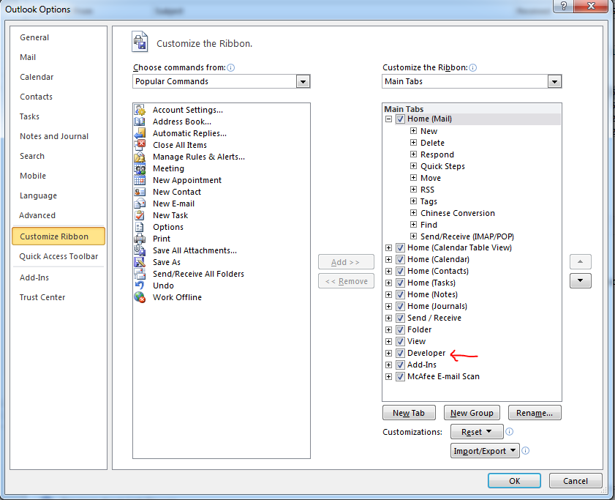

1. Create a Macro:

* Developer 🡪 Macros 🡪 Macros
* Type the name you wish to give to the macro (e.g. AttachmentReminder) and hit “Create”
* The above step should open up a new window with Visual Basic code:

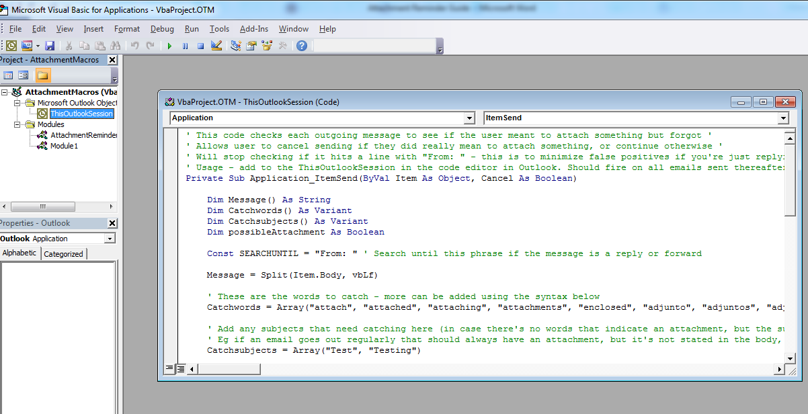

* Make sure that you delete everything from the editor and copy and paste the code I have provided in a separate file.
* Then the new code with ***Ctrl + S***.
* Close the window and restart Outlook

1. Test if the Macro is working:

Try to send an email to yourself with the words "attach", "attached", "attaching", "attachments", "enclosed", "adjunto", "adjuntos", "adjunta", "adjuntas", "anexo", "anexa", "anexos", "anexas".

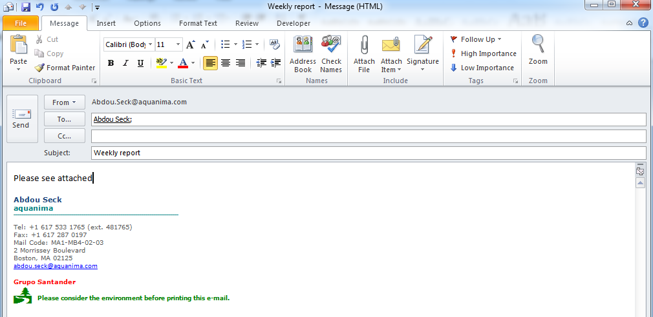

You should get a reminder when you hit “Send” without having attached your file.

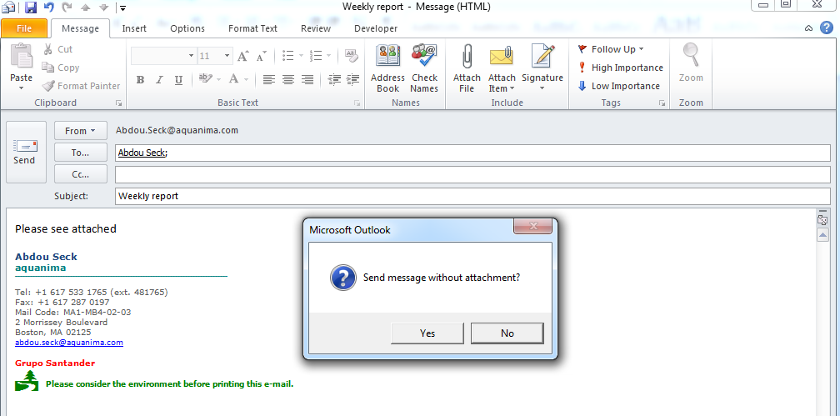

Please keep in mind that sometimes you will get false positives; basically that prompt box will show sometimes when you did not intend to attach any files. In cases like that, click Yes to send your email without attachment. Furthermore, it should be mentioned that this will work as long as the language used to write the email is either Spanish or English. If anyone wishes to have the macro work for Portuguese or German, please send me the ***most common words/expressions*** used in Portuguese or German to indicate that a file is to be attached.